Measures of Dispersion (Variation)
The measure of central tendency helps us in describing a set of data by a single number or typical value. However, they do not provide us any information about the extent to which the values differ from one another or from the average value. Hence, to increase our understanding of the pattern of a data, we must also measure its dispersion- indicates the degree to which the numerical data tend to spread or variability about an average value. The scatter or spread of items of a distribution is known as dispersion or variation.
The measures of dispersion also enable us to compare several samples with similar averages.
Consider the following data sets:
Set 1: 60 40 30 50 60 40 70 50
Set 2: 50 49 49 51 48 50 53 50
Set 3: 50 50 50 50 50 50 50 50
The three data sets have a mean of 50, but obviously set 1 is more “spread out” than set 2 and set 3 has no variability.
Objectives
The general object of measuring dispersion is to obtain a single summary figure which adequately exhibits whether the distribution is compact or spread out.
• To judge the reliability of measures of central tendency
• To control variability itself.
• To compare two or more groups of numbers in terms of their variability.
• To make further statistical analysis.
Absolute and Relative Measures of Dispersion
The measures of dispersion which are expressed in terms of the original unit of a series are termed as absolute measures. Such measures are not suitable for comparing the variability of two distributions which are expressed in different units of measurement and different average size. Relative measures of dispersions are a ratio or percentage of a measure of absolute dispersion to an appropriate measure of central tendency and are thus pure numbers independent of the units of measurement. For comparing the variability of two distributions (even if they are not measured in the same unit), we compute the relative measure of dispersion instead of absolute measures of dispersion.
Types of Measures of Dispersion
It is useful for comparing variation in two or more distributions where units of measurements are the same. Various measures of dispersions are in use. The most commonly used measures of dispersions are:
1) Range and Relative Range
2) Quartile Deviation and Coefficient of Quartile Deviation
3) Mean Deviation and Coefficient of Mean Deviation
4) Standard Deviation and Coefficient of Variation.
The Range (R)
The range is the largest value minus the smallest value in a data set. The range is greatly affected by extreme values. Range = largest value – smallest value.
The following two distributions have the same range, 13, yet appear to differ greatly in the amount of variability.
Distribution 1: | 32 | 35 | 36 | 36 | 37 | 38 | 40 | 42 | 42 | 43 | 43 | 45
Distribution 2: | 32 | 32 | 33 | 33 | 33 | 34 | 34 | 34 | 34 | 34 | 35 | 45
For this reason, among others, the range is not the most important measure of variability.
Merits and Demerits of range
Merits:
• It is rigidly defined.
• It is easy to calculate and simple to understand.
Demerits:
• It is not based on all observation.
• It is highly affected by extreme observations.
• It is affected by fluctuation in sampling.
• It cannot be computed in the case of open end distribution.
• It is very sensitive to the size of the sample.
Relative Range (RR)
It is also sometimes called coefficient of range and given by:
RR = 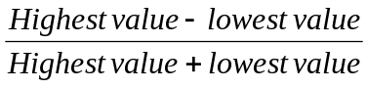
Example:
1. Find the relative range of the above two distribution. (Exercise!)
2. If the range and relative range of a series are 4 and 0.25 respectively. Then what is the value of:
a) Smallest observation (Ans. 6)
b) Largest observation (Ans. 10)
The Quartile Deviation (Semi-inter quartile range), Q.D
The inter quartile range is the difference between the third and the first quartiles of a set of items.
IQR = Q₃ – Q₁, and semi-inter quartile range is half of the inter quartile range.
Q.D =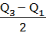
Coefficient of Quartile Deviation (C.Q.D)
C.Q.D = 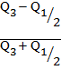 = 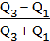
Remark: Q.D or C.Q.D includes only the middle 50% of the observation.
The Mean Deviation (M.D):
The mean deviation of a set of items is defined as the arithmetic mean of the values of the absolute deviations from a given average. Depending up on the type of averages used we have different mean deviations.
Mean Deviation about the mean for a data set x_{1,} x_{2…………..}, x_{n}
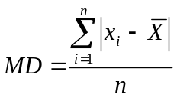,

For the case of a frequency distribution data where the values X₁, X₂, X₃, …,X_{k} occur f₁, f₂, f₃, …, f_{k} times respectively, then mean deviation is obtained by: MD = 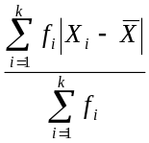
If the data is given in the form of frequency distribution of k-classes in which m_{i} and f_{i} are the class marks and frequency of the i^{th} class respectively then the mean deviation is given by: MD = 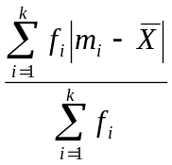
Steps to calculate M.D:
1. Find the arithmetic mean,
2. Find the deviations of each reading from 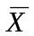and
3. Find the arithmetic mean of the deviations, ignoring sign.

Example: calculate the mean deviation for the following data:
X_{i} | 10 8 9 7 6
f_{i} | 8 9 13 6 3
Solution: first find the mean as = 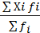 = (10*8 + 8*9 +…+6*3)/(8+9+…+3) = 8.4, then
X_{i} | 10 | 8 | 9 | 7 | 6
f_{i} | 8 | 9 | 13 | 6 | 3
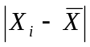 | 1.6 | 0.6 | 0.4 | 1.4 | 2.4
f_{i} | 12.8 | 7.8 | 3.6 | 8.4 | 7.2
Thus, MD = = 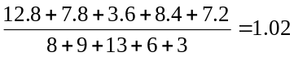
Interpretation: each value deviates on average 1.02 from the arithmetic mean, 8.4.
Coefficient of Mean Deviation (C.M.D)
CMD = 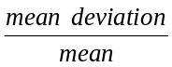
The Variance and Standard Deviation
The variance
The variance is the "average squared deviation from the mean" and it measures the average of the square of the deviations from the mean for each observations.
Suppose we have population of N observations, say X₁, X₂, X₃, …, X_{N}, then we define the population variance as:
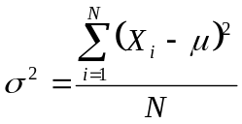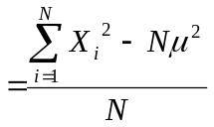
But most of the time we have sample of n observations, say X₁, X₂, X₃, …, X_{n} from the population of N, then we define the sample variance as:
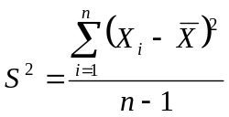 ,or 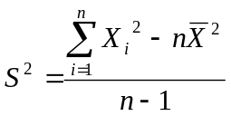 ,or 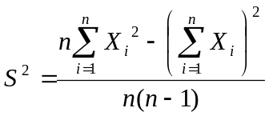
This measure of variation is universally used to show the scatter of the individual measurements around the mean of all the measurements in a given distribution. But the disadvantage is that the units of variance are the square of the units of the original observations. The easiest way for this difficulty is to use the square root of the variance as a measure of variability called the standard deviation.
Standard deviation
The population and the sample standard deviations denoted by σ and S respectively are defined as:
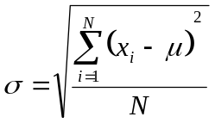 , where 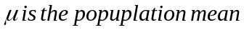
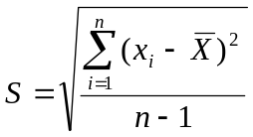 where 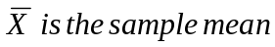
For the case of frequency distribution data the population and sample variance are given as: 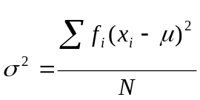 , where N = 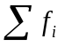
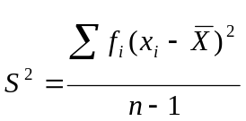 ,where n =
Variance and Standard Deviation for Grouped Data
The sample variance for a grouped frequency distribution is given by
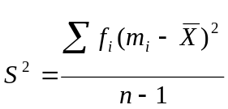 , where n = , m_{i} = midpoint of i^{th} class
Example: Areas of spray able surfaces with DDT from a sample of 15 houses are as follows (m²): 101, 105, 110, 114, 115, 124, 125, 125, 130, 133, 135, 136, 137, 140, 145. Find the variance and standard deviation..
Solution: The mean of the sample is 125 (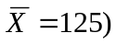, then
= 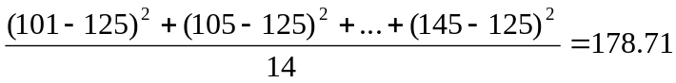
Hence, the standard deviation = S =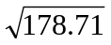 = 13.37.
Examples: Find the variance and standard deviation of the following grouped sample data
Class | Frequency
40-44 | 7
45-49 | 10
50-54 | 22
55-59 | 15
60-64 | 12
65-69 | 6
70-74 | 3
Sample mean, = 55, n=75

m_{i}(midpoint) | 42 | 47 | 52 | 57 | 62 | 67 | 72 | Total
f_{i}(m_{i}- )² | 1183 | 640 | 198 | 60 | 588 | 864 | 867 | 4400
Then = 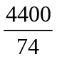 = 59.46
And S = 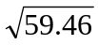 = 7.71
Note:
If the standard deviation of X₁, X₂, ….., X_{n} is S, then the standard deviation of
- X₁+ k, X₂+k, …, X_{n}+k will also be S (where k =constant)
- kX₁, kX₂, …, kX_{n} will be |k|S.
- c+kX₁, c+kX₂, …,a+ kX_{n} will be |k|S ( c and k are constants)
Example1: The standard deviation of n observations X₁, X₂, ...., Xn is known to be 3. New set of observations are obtained by the linear transformation Y_{i} = 2X_{i}– 0.5 ( i = 1, 2, …, n ), then what will be the standard deviation of the new set of observations.
Solution: new standard deviation = |k|S = 2*3 =6
Example 2: The mean and the standard deviation of a set of numbers are respectively 500 and 10.
- If 10 is added to each of the numbers in the set, then what will be the variance and standard deviation of the new set?
- If each of the numbers in the set are multiplied by -5, then what will be the variance and standard deviation of the new set?
Solutions: a) The variance and standard deviation will remain the same.
b) New standard deviation= |k|S =5*10 =50
Coefficient of Variation (CV)
The coefficient of variation (CV) is defined by
CV= 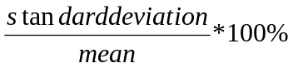
CV= 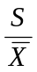 *100%.
The coefficient of variation is most useful in comparing the variability of several different samples, each with different means. This is because a higher variability is usually expected when the mean increases, and the CV is a measure that accounts for this variability. CV is a relative measure free from unit of measurement.
Examples: An analysis of the weekly wages paid (in Birr) to workers in two firms A and B belonging to the same industry gives the following results.
In which firm the wages is more variable?
Value | Firm A | Firm B
Mean wage | 56 | 72
Variance | 10 | 11
Solution: C.V_{A} = *100% = 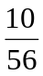*100% = 17.86% and
C.V_{B} = *100% = 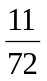*100%= 15.28%.
Since C.V_{A} > C.V_{B} in A there is greater variability in individual wages.
The standard Score (Z-score):
It is the number of standard deviations that a given value X is below or above the mean.
The standard score of any value X_{i} is defined as
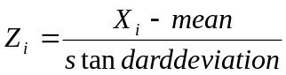
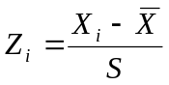 (for the sample data sets)
Values above the mean have positive z-scores and values below the mean have negative Z-scores. Z-scores are generally meaningless by themselves unless they are compared to the distribution or scores from some reference group.
Note: A Z-score value less than -2 and greater than 2 considers as unusually low or high value.

Example 1: Two sections were given introduction to statistics examinations. The following information was given.
Value | Section 1 | Section 2
Mean | 78 | 90
Standard deviation | 6 | 5
Student A from section 1 scored 90 and student B from section 2 scored 95. Relatively speaking who performed better?
Solution: = 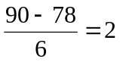 and
= 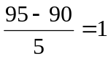
Student A performed better relative to his section because the score of student A is two standard deviation above the mean score of his section while, the score of student B is only one standard deviation above the mean score of his section.
Example 2: Two groups of people were trained to perform a certain task and tested to find out which group is faster to learn the task. For the two groups the following information was given:
Value | Group one | Group two
Mean | 10.4 min | 11.9 min
Stan.dev. | 1.2 min | 1.3 min
Relatively speaking:
a) Which group is more consistent(less variable) in its performance?
b) Suppose a person A from group one takes 9.2 minutes while person B from Group two takes 9.3 minutes, who was faster in performing the task? Why?
Solutions:
a) Use coefficient of variation.
CV₁ = 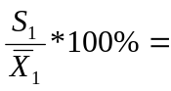 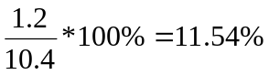
CV₂ = 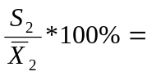 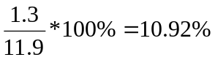
Since C.V2 < C.V1, group 2 is more consistent (less variable)
b) Calculate the standard scores of A and B
= 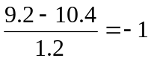 and
= 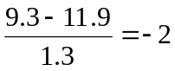
Person B is faster because the time taken by person B is two standard deviation shorter than the average time taken by group 2 while, the time taken by person A is only one standard deviation shorter than the average time taken by group 1
Moments

If X is a variable that assume the values X₁, X₂,…..,X_{n} then

- The r^{th} moment is defined as:
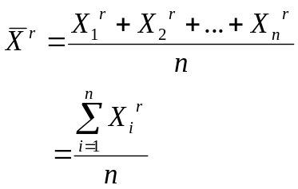
- For the case of frequency distribution this is expressed as:
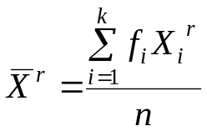
- If 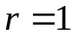, it is the simple arithmetic mean, this is called the first moment.

- The r^{th} moment about the mean ( the r^{th} central moment)
Denoted by M_{r} and defined as:
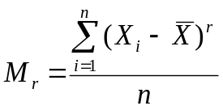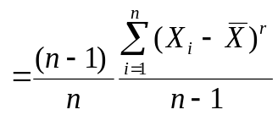
- For the case of frequency distribution this is expressed as:
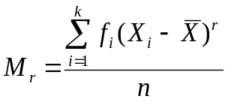
- If 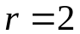, it is population variance, this is called the second central moment. If we assume 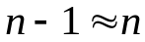, it is also the sample variance.

- The r^{th} moment about any number A is defined as:
- Denoted by 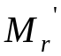and
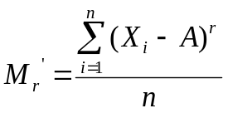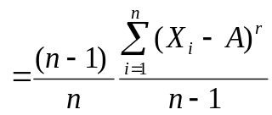
- For the case of frequency distribution this is expressed as:
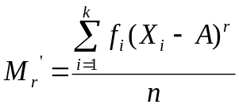
Example:

- Find the first two moments for the following set of numbers 2, 3, 7
- Find the first three central moments of the numbers in problem 1
- Find the third moment about the number 3 of the numbers in problem 1.
Solutions:
- Use the r^{th} moment formula.
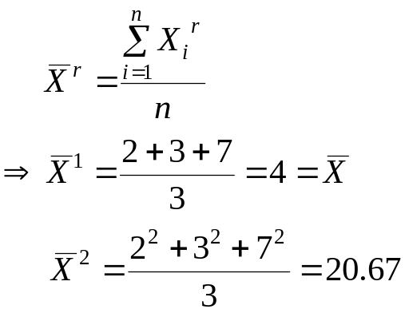
- Use the r^{th} central moment formula.
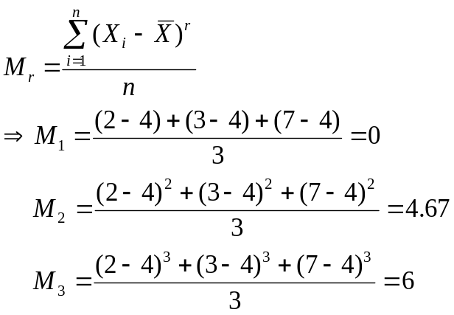
- Use the r^{th} moment about A.

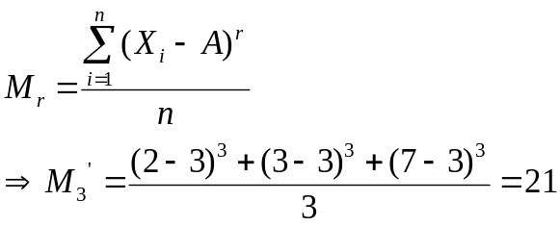
Skewness
- Skewness is the degree of asymmetry or departure from symmetry of a distribution.
- A skewed frequency distribution is one that is not symmetrical.
- Skewness is concerned with the shape of the curve not size.
- If the frequency curve (smoothed frequency polygon) of a distribution has a longer tail to the right of the central maximum than to the left, the distribution is said to be skewed to the right or said to have positive skewness. If it has a longer tail to the left of the central maximum than to the right, it is said to be skewed to the left or said to have negative skewness.
- For moderately skewed distribution, the following relation holds among the three commonly used measures of central tendency.
Measures of Skewness
- Denoted by 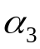
- There are various measures of skewness.
- The Pearsonian coefficient of skewness
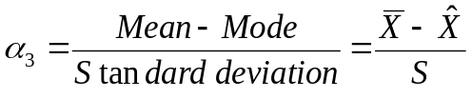
- The Bowley’s coefficient of skewness ( coefficient of skewness based on quartiles)
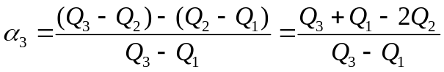
- The moment coefficient of skewness
The shape of the curve is determined by the value of 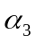

Remark:
- In a positively skewed distribution, smaller observations are more frequent than larger observations. i.e. the majority of the observations have a value below an average.
- In a negatively skewed distribution, smaller observations are less frequent than larger observations. i.e. the majority of the observations have a value above an average.

Examples:
- Suppose the mean, the mode, and the standard deviation of a certain distribution are 32, 30.5 and 10 respectively. What is the shape of the curve representing the distribution?

Solutions:

Use the Pearsonian coefficient of skewness
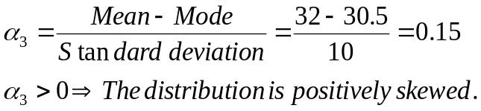
- In a frequency distribution, the coefficient of skewness based on the quartiles is given to be 0.5. If the sum of the upper and lower quartile is 28 and the median is 11, find the values of the upper and lower quartiles.

Solutions:
Given: 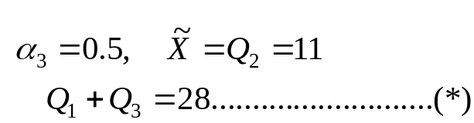 Required: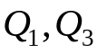

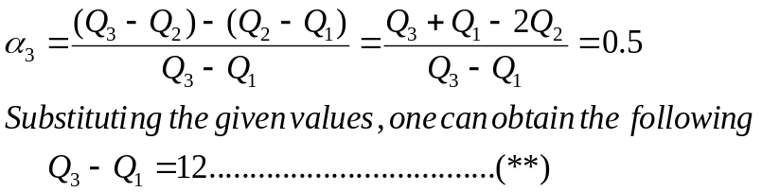
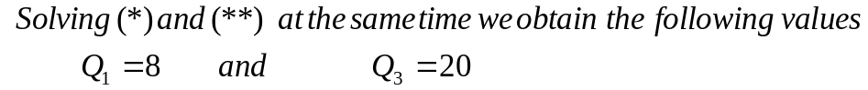

Exercises:
- Some characteristics of annually family income distribution (in Birr) in two regions is as follows:
Region | Mean | Median | Standard Deviation
A | 6250 | 5100 | 960
B | 6980 | 5500 | 940
- Calculate coefficient of skewness for each region
- For which region is, the income distribution more skewed. Give your interpretation for this Region
- For which region is the income more consistent?

- For a moderately skewed frequency distribution, the mean is 10 and the median is 8.5. If the coefficient of variation is 20%, find the Pearsonian coefficient of skewness and the probable mode of the distribution.

- The sum of fifteen observations, whose mode is 8, was found to be 150 with coefficient of variation of 20%
- Calculate the pearsonian coefficient of skewness and give appropriate conclusion.
- Are smaller values more or less frequent than bigger values for this distribution?
- If a constant k was added on each observation, what will be the new pearsonian coefficient of skewness? Show your steps. What do you conclude from this?
Kurtosis
Kurtosis is the degree of peakdness of a distribution, usually taken relative to a normal distribution. A distribution having relatively high peak is called leptokurtic. If a curve representing a distribution is flat topped, it is called platykurtic. The normal distribution which is not very high peaked or flat topped is called mesokurtic.

Measures of kurtosis
The moment coefficient of kurtosis:
- Denoted by 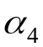 and given by
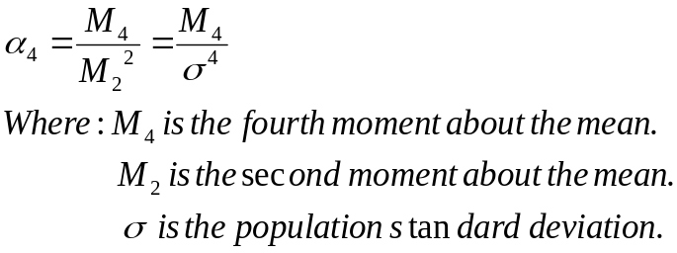
The peakdness depends on the value of.
Examples:
  - If the first four central moments of a distribution are:
    - Compute a measure of skewness
    - Compute a measure of kurtosis and give your interpretation.

Solutions:
- 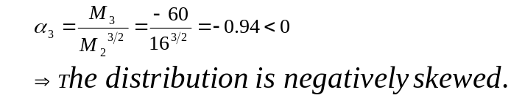

- 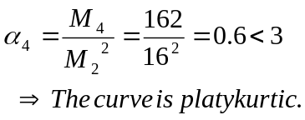
Exercise:
- The median and the mode of a mesokurtic distribution are 32 and 34 respectively. The 4th moment about the mean is 243. Compute the Pearsonian coefficient of skewness and identify the type of skewness. Assume (n-1 = n).
- If the standard deviation of a symmetric distribution is 10, what should be the value of the fourth moment so that the distribution is mesokurtic?

